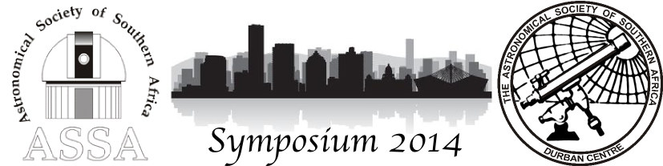

ASSA DURBAN PO BOX 20578 DURBAN NORTH SOUTH AFRICA 4016
www.astronomydurban.co.za/symposium www.facebook.com/Assasymposium2014

The Astronomical Society of Southern Africa; Durban Centre, Invite you to attend the upcoming 2014 Symposium.
Date: 24 to 27th September 2014.
Theme: “Astronomy South Africa; beyond SALT and SKA”.
Venue: Durban University of Technology campus on the Berea Durban
Cost: R550.00pp
To register for the Symposium go to: http://www.astronomydurban.co.za/Symposium.aspx
This is the first call for papers, please email your abstracts to
Frikkie de Bruyn: debruyn1@telkomsa.net

CHAIRMAN : Logan Govender SECRETARY : Francois Zinserling PAPERS: Frikkie de Bruyn
+27 83 228 6993 +27 83 256 2424 +27 82 255 1690

